1. 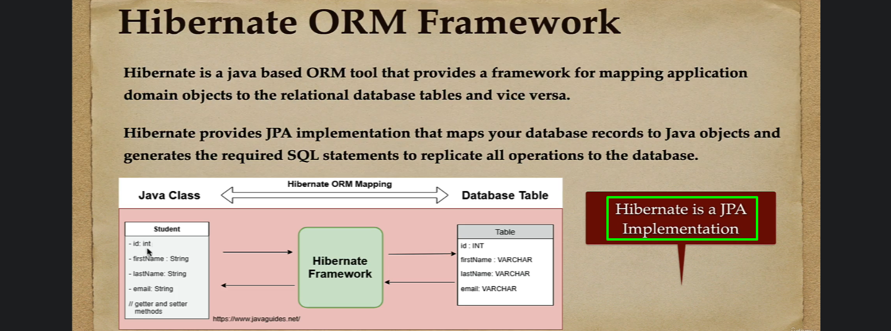
2. 
3. When we try to insert an object into DB via hibernate, it will generate SQL Query behind the scenes and will execute that insert query using JDBC with respect to the DB.  
   That is why ORM is very important tool to work with DB using Java Object rather than
4. 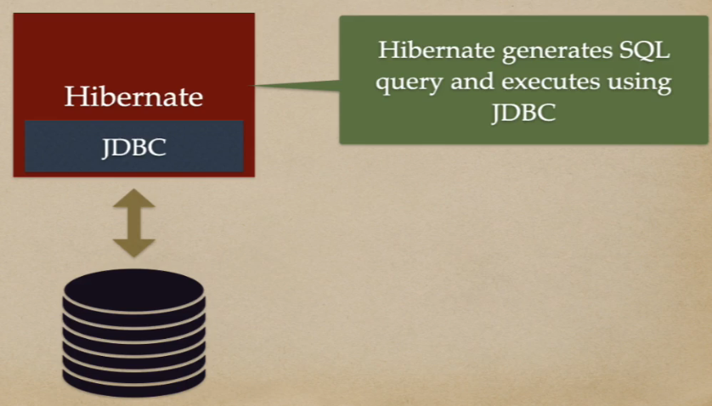
5. 